R. Reports Menu: 1. Invoice Edit List

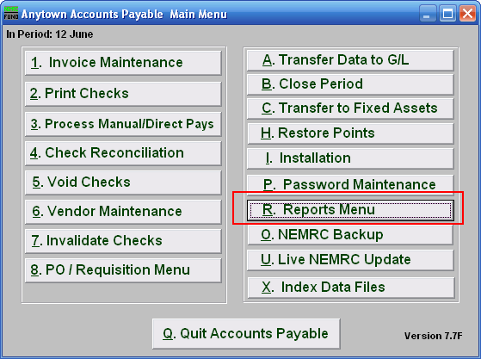
Click on “R. Reports Menu” from the Main Menu and the following window will appear:

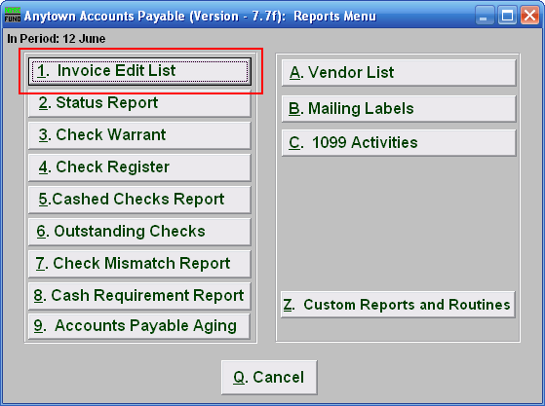

Click on “1. Invoice Edit List” from the Reports Menu and the following window will appear:
Invoice Edit List

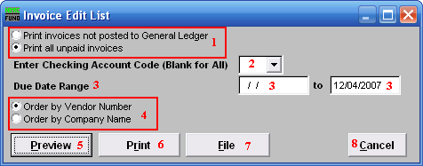

- Print invoices not posted… OR Print all unpaid ...: The default is to print and review all unpaid invoices. This practice is most common for invoice entry occurring at the same time of check preparation. When invoices are entered, reviewed and transferred on a daily basis then use the other option. The second method of entry shows results on the budget status report without requiring checks to be printed first.

- Enter Checking Account Code (Blank for All): When multiple checking accounts are in use then you may restrict the report to a single account by selecting one from the drop down menu.

- Due Date Range: Enter the beginning and ending due dates on the invoices to report. The default of an empty beginning date is to ensure all unpaid invoices from voided checks re-appear in the report for unpaid invoices.

- Order by Vendor OR Order by Company: Select the order in which to report the information.

- Preview: Click this button to preview this report. Refer to GENERAL PREVIEW for more information.

- Print: Click this button to print this report. Refer to GENERAL PRINTING for more information.

- File: Click this button to save this report on this computer. Refer to GENERAL FILE for more information.

- Cancel: Click “Cancel” to cancel and return to the previous screen.

